4.a. Temperature range that require idling to warm the engine up - THE THERMOSTAT WILL NOT SEND WATER TO THE COOLING SYSTEM UNTIL THE WATER TEMP REACHES 71 C.  SEE PICTURE BELOW:

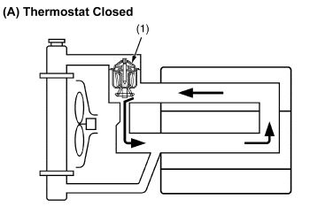

4.b. Temperature range that can work properly - THE THERMOSTAT WILL SEND WATER THROUGH THE COOLING SYSTEM BETWEEN THE TEMPERATURES OF 71 C AND 107 C.  SEE PICTURE BELOW:

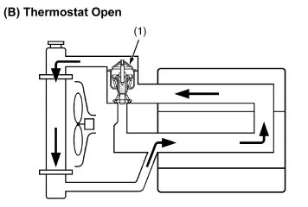

4.c.  Temperature range that should pay attention - THE WATER TEMP RANGE NEEDS TO BE LESS THAN 107 C.

4.d.  Temperature range that could cause overheating - THE ENGINE CAN OVER HEAT WHEN THE WATER TEMP GETS ABOVE 110 C.

5.a. Minimum psi (at high engine speed) that requires check/inspection - THE OIL PRESSURE SHOULD NOT DROP BELOW 7 PSI.

5.b. Correct psi range - THE OIL PRESSURE PUMP DELIVERS A RANGE OF 28 TO 64 PSI AND IS CONTROLLED BETWEEN 35.6 TO 49.8 PSI.

5.c.  Maximum psi that require check/inspection - THE OIL PRESSURE SHOULD NOT EXCEED 49.8 PSI.

BELOW IS A STANDARD LUBRICATION SYSTEM DIAGRAM, I FIGURE IT MAY HELP.

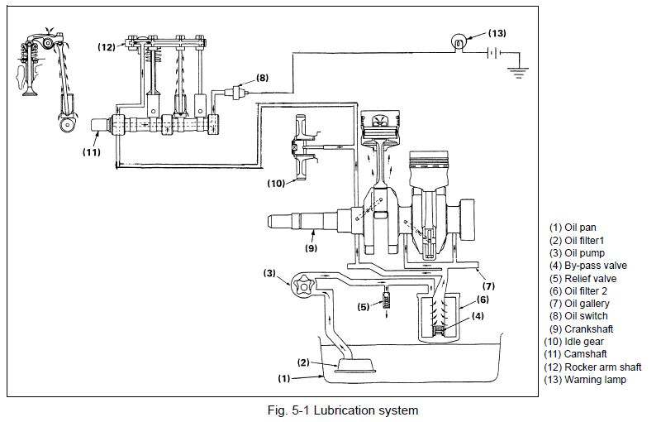

I need to get your help with a few questions and need to send the response back to Japan by Thursday. They are wanting to know on the 6X DSL D902 the below, I copied in what they asked.

4. Water temperature in the engine

a. Temperature range that require idling to warm the engine up  b. Temperature range that can work properly  c. Temperature range that should pay attention  d. Temperature range that could cause overheating

5. Engine oil pressure

a. Minimum psi (at high engine speed) that requires check/inspection  b. Correct psi range  c. Maximum psi that require check/inspection